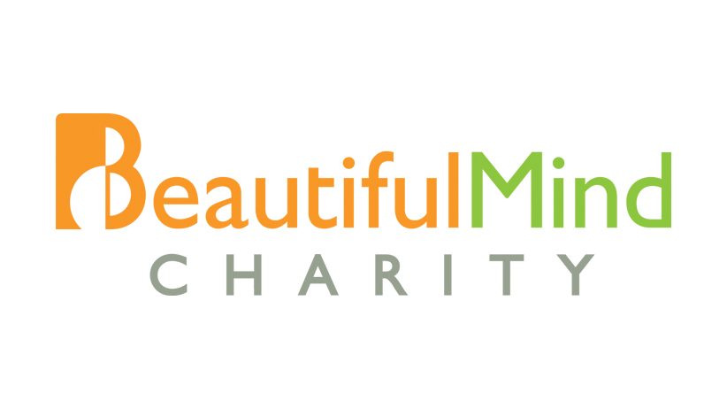
Please attach recent photo

VOLUNTEER APPLICATION FORM

- MY PERSONAL PARTICULARS
Name: |  |  |  | NRIC/FIN:
Date of Birth: |  |  |  | Marital Status:
Citizenship: |  |  |  | Occupation:
Languages/dialects spoken:
Home Address:
Postal Code: |  |  |  | Email Address:
Contact No: | Home: |  |  |  | Mobile:

- VOLUNTEERING HELP

Please indicate if you are able to volunteer with the following other than your area of expertise:

- Volunteer driver [ Yes / No ]
(Drive students with disabilities from their home to music studio and back)

- Chaperone [ Yes / No ]
(Accompany students with disabilities from their home to music studio and back)

- Administration / Event [ Yes / No ]
(Help with administration and event logistics)

- Editorial / Website / Design [ Yes / No ]
(Writing and editing newsletter, design website/newsletter/brochure)

- Any others, please list:

3. DECLARATION

Have you ever been convicted of a criminal charge? [Yes / No]
If you have indicated “Yes”, please provide details below

The information provided in this application are ttrue and accurate to the best of my knowledge. I understand that any willful act on my part in withholding information or making false statements in the application form is in itself, sufficient grounds for dismissal from the Volunteer Programme.

____________________________________ _______________________________
Name NRIC / FIN

____________________________________ ________________________________ Signature Date

